Shoot Your Way Out

DESIGN DOCUMENT

By Qazer12 for the 2025 Pirate Software Game Jam

**Introduction**

**Game Summary Pitch** 2

**Inspiration** 2

**Player Experience** 4

**Platform** 4

**Development Software** 4

**Genre** 4

**Target Audience** 4

**Concept** 5

**Gameplay overview** 5

**Theme Interpretation (You Are The Weapon)** 5

**Primary Mechanics** 5

**Controls** 6

## **Introduction**

### **Game Summary Pitch**

Shoot Your Way Out is a puzzle game where the goal is to shoot one or more targets at the end of a level with a single bullet. To do this, you’ll have one primary gun loaded with one bullet that will be in a static position, you will then have to place movable revolvers in a 2D level to make sure that they recover the bullet you shoot with the primary revolver and shoot it again, but in a different direction. you’ll also have knives that will cut a bullet in half to shoot 2 targets with only one bullet. The goal will be to place the weapons correctly so that they can hit the target at the end.

### **Inspiration**

**JoJo’s bizarre adventure**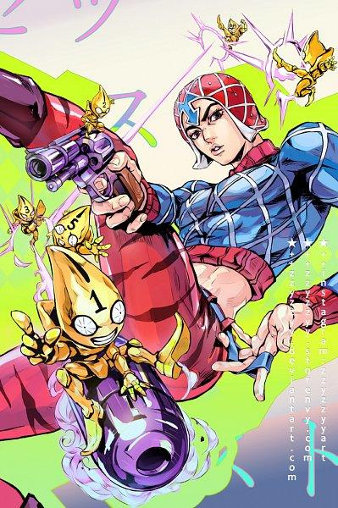

It isn’t a game, but the concept of the game was inspired by The character Guido Mista from the manga JoJo’s bizarre adventure part 5. He has the power to summon six little flying characters that can kick every bullet he shoots to make sure that he never misses a shot.

Mista fan art made by zzyzzyy on deviant art

**Enter the gungeon**

The visual of the game is also inspired by enter the gungeon. The weapon animations, pixel art and how the little bullet are sentient really inspired me for the art direction of Shoot Your Way Out

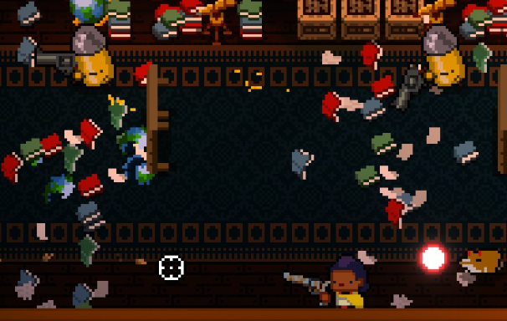

**Framed collection**

Framed is a puzzle game where the player’s goal is to manipulate the panels of a comic book to move the player towards an exit. The first and last comic box of each level are fixed, and all other boxes can be changed to allow the character to reach his goal. The concept of having a fixed gun at the start and one or more fixed targets at the end is greatly inspired by this game.

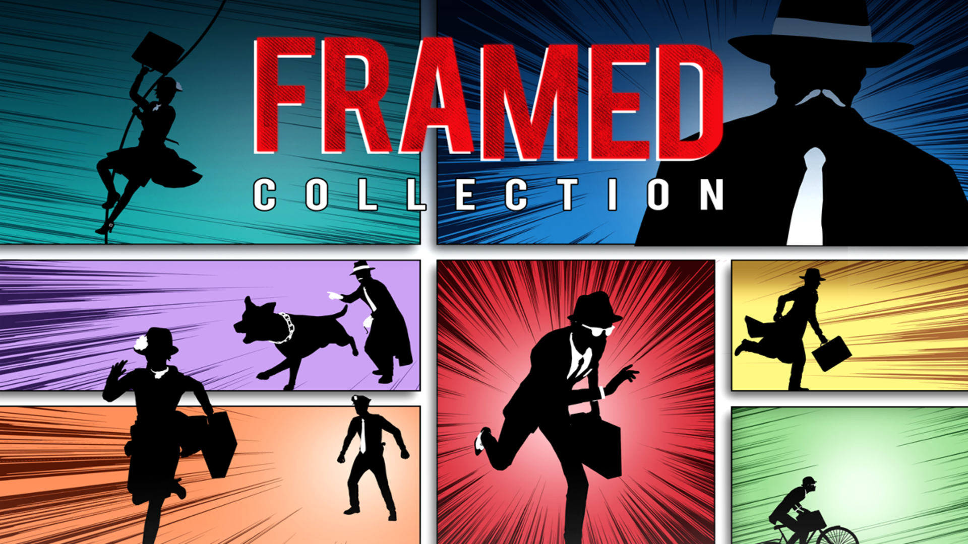

### **Player Experience**

For each level, a primary weapon will be placed at the start and one or more targets at the end. The player will have a preparation phase where he will be able to place every weapon he has. After he finishes, he can press the shoot button and then the game will switch into shooting mode, where he will see where the bullet goes and how he can change his plan if he misses the target.

### **Platform**

The game is developed to be released on windows PC

### **Development Software**

* Godot 4.3 for programming
* Aseprite for sprites and UI

### **Genre**

Single Player, puzzle game

### **Target Audience**

The game will be targeted for casual and also more advanced players. Casual players will mostly use every weapon they have to finish a level with an easy/medium difficulty. Where more advanced players might want to optimize every run by using a minimum number of weapons with a more challenging game mode where you have less weapons in your inventory.

## **Concept**

### **Gameplay overview**

The player will have a limited amount of weapons that they can place in a level. Each weapon can be placed in a predefined weapon location in a 2D space. Each level will have several specific locations where the player can place a weapon. Once the weapon is placed, the player can make rotations to decide on the future trajectory of the bullet. He will also be able to place knives to cut the bullet and hit two targets with one shot.

### **Theme Interpretation (You Are The Weapon)**

The only way to advance through the levels is to shoot at the final target. The bullet is what makes the player win, but to do that he needs to redirect his trajectory so it can reach its goal. To achieve it, the player must think about how best to redirect the bullet so that it reaches its destination. A conventional weapon cannot redirect a bullet after it shoots, but the player, thanks to his

intelligence, is an appropriate weapon to bring the bullet to its goal

### **Primary Mechanics**

| **Mechanic** |
| --- |
| **Revolver** a  A revolver picks up the bullet that is shot at it to shoot it again in another direction |
| **Knife** a  The knife separates the ball in two to be able to hit more target with a single bullet |

### **Controls**

**Mouse:**

-Drag and drop a weapon in a weapon slot

-Right click on a weapon to rotate it